IT1060 – Software Process Modeling 2022 - July

# Assignment 2 Cover Sheet

|  |  |
| --- | --- |
| **CASE STUDY NAME** | Online Marketplace |
| **PROJECT ID** |  |

Group Details:

|  |  |  |
| --- | --- | --- |
|  | **Student Registration Number** | **Student Name** |

IT1060 – Software Process Modeling 2022 - July

# Assignment 2 Certify Sheet

We hereby certify,

The attached is my own work and no further changes will be made.



I have contributed in this assignment to the best of my ability.

And I understand,

I may be subject to student discipline processes in the event of an act of academic misconduct by me including an act of plagiarism or cheating.



Student Details:

|  |  |  |  |
| --- | --- | --- | --- |
| **Student Name** | **Student Registration** | **Date** | **Signature** |
| **Number** |
|  |  |  |  |

**Part I**

1. Use Case Scenario

|  |  |  |
| --- | --- | --- |
| **Number** | UCS013 | |
| **Name** | Add new customers | |
| **Summary** | Evaluate applicants and add them to the system | |
| **Pre-conditions** | Customers are added to the Database | |
| **Post-conditions** | Validate customer details and add to the system | |
| **Primary Actor** | System Database | |
| **Main Scenario** | **Step** | **Action** |
|  | 1 | System gets notified when new customer clicks register button |
| 2 | System displays the register form |
| 3 | Customer enters the email, password, and confirmation password |
| 4 | System checks whether the email is a valid one |
| 5 | System checks whether the password and confirmation password matches |
| 6 | System Enables the sign-up button |
| 7 | System sends a confirmation email to the user after the user clicks the signup button |
| 8 | System displays a message to confirm the email after the user get sign up |
| 9 | System awaits until the user confirms the email sent |
| 10 | User confirms the email |
| 11 | System then adds the new customer to the data base and updates the data base |
| 12 | System directs the customer to the home page |
| **Extensions** | **Step** | **Action** |
|  | 4a | System notifies if the email is not valid |
| 5a | System notifies if the passwords given doesn't match |
| 5b | System notifies the customer to update personal details |
| 10a | System checks whether the user has multiple accounts |
| 10b | System generates reports of the new customer |

**Activity Diagram – Without Partition**

**Part II**

1. Sub-systems of Online Marketplace

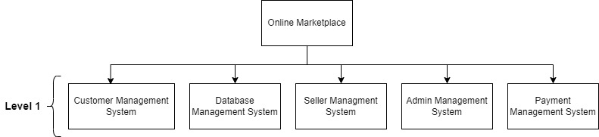

**Activity Diagram – With partitioning**

Clear Diagram:

Clear Diagram:

